46 Exhibition **NSW**

River of **visions**

Art and history cover a lot of territory when they follow the great

Murrumbidgee, writes Tom Middlemost. Australian landscapes, write

**The Big River Show: Murrumbidgee Riverine**

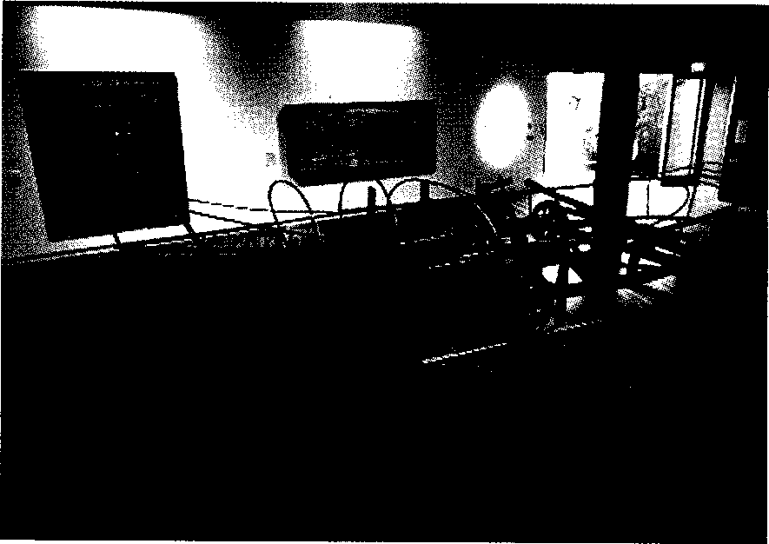

A glimpse of The Big River Show at Wagga Wagga Regional Art Gallery.

Wagga Wagga Regional Art Gallery (ended December 1)

In early 2003, while relaxing on the banks

of the Murrumbidgee at "Wagga Wagga

beach", my mind wandered and filled with images of the Big River Show: Murrumbidgee Riverine from late last year. The show attracted 3,86o visitors — a consid­erable number for Wagga Wagga despite being open for less than two months. Curated by Gavin Wilson, it was an artistic, historical and social study of the Murrumbidgee, from its headwaters at Fiery Range near the Tantangara Reservoir, to its confluence with the Murray south-west of Balranald. The exhibition and accompanying publication chronicled its history and chang­ing character, from the wild river mapped by Sturt and Macleay in 1829, to the highly regu­lated river of today.

In the Big River Show one was initially con­fronted with Rosalie Gascoigne's four-metre­long, soft-drink crate assemblage *Scrub Country* 0984, and *Echo* (2002), by Imants Tillers, both portraying the Monaro at the source of the river. Gascoigne's "CRYSTAL" blue crates seemed to wend their way through the weathered landscape, while Tillers' wispy, blue thread of the Murrumbidgee in the top left barely touched the glowing, battered ground.

*The Plough* (1988), by Gordon Bennett, reversed our view of the landscape by graphi­cally depicting indigenous Australians' loss of life and land under the feet of the farmer. The same artist's Aborigine painting *(the inland sea) (1994)* referred to the subjugation of Aborigines, and incorporated a wrecked boat as a reference to the explorers John Oxley and Charles Sturt's futile search for an inland sea.

Nearby, the explorer theme was echoed by

two wonderful Arthur Wicks sculptures, *Relic of a Survival Boat* (1984) and *The Boatman's Unscheduled Crossing* (2002), both versions of an evolved and wheeled whaling boat. The latter, a frantic piece that stole the show at the opening, is included in the 2003 National Sculpture Prize at the National Gallery of Australia. A miniature man in a boat rows his way along a tenuously fine track above the viewer's head.

Elioth Gruner's *On the Murrumbidgee* (1929) shows the winter plains around Yass, strongly at odds with the drought-ravaged landscape of today. Sturt wrongly described the area as sparsely populated by Aborigines. A century later Gruner painted the disastrous results of farming, which degraded both the environment and the indigenous culture. These rather dull, pastoral idylls were very popular, with Gruner winning the Wynne Prize seven times.

Hay is located on a tediously level plain three-quarters of the way down the Murrumbidgee. Ludwig Hirschfeld Mack was interned there after arriving from England on the ship Dunera in 1940. While in detention, he produced the most stirring work in the exhibition — an existentialist woodcut titled *Desolation, Internment Camp Hay, NSW* (1940-1). The print is dark, minimal in line, and poignantly topical, as it depicts a lone

migrant under the Southern Cross, welcomed not with a hand­shake but with a fence of barbed wire.

Elwyn Lynn's work on paper *Silver Murrumbidgee* (1990) reflected the path of the river and the migrants that settled near it. The colours of the Italian flag in one corner suggested the Italians near Griffith; a piece of gold-embossed paper possibly referred to the Chinese migrants of Wagga Wagga. In Russell Drysdale's *Maria* (1950) the dislocated yet resilient Greek migrant became an inte­gral, almost structural part of the image, and by inference the township. By serving steak and eggs, it seems migrants can be accepted as part of everyday life.

Three hand-coloured etchings by Yorta Yorta artist Treahna Hamm, *Paradise Overkill* (1995), *Murrumbidgee River* (1998) and *Riverina Landscape* (1999), depicted a detailed, fertile, almost sentient landscape peopled with spirit beings. To my mind, part of a continuing dreaming of the area.

This glimpse suggests the depth of the selection. There were also works by Denis Allard, John Caldwell, John Carney, Jeff Carter, Margaret Cohen, Beryl Feron, Shay Docking, Barry Gazzard, Roy Kennedy, John Olsen, Michael Ramsden, Michael Taylor, Anita Wickey, John Wolseley and Anne Zahalka. Wagga Wagga Regional Art Gallery initiated the project and much credit must go to the gallery team, led by Louise Doyle, Kirsty

Davies and Sarah Last. ◼

*Toni Middelmost works at Charles Sturt University, Wagga Wagga.*